1.
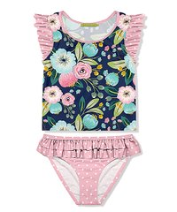NYSIL108058 12m, 18m, 24m, 2T, 3T, 4T, 5, 6, 6x, 8, 10, 12
$ 16

2.
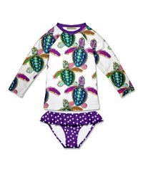NYSIL103159 12m, 18m, 24m, 2T, 3T, 4T, 5, 6, 6x, 8, 10, 12
$17

3.
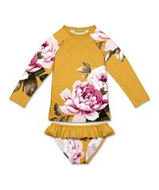NYSIL103052 12m, 18m, 24m, 2T, 3T, 4T, 5, 6, 6x, 8, 10, 12
$17
4.
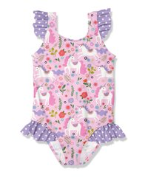NYSIL101170 12m, 18m, 24m, 2T, 3T, 4T, 5, 6, 6x, 8, 10, 12
$14
5.
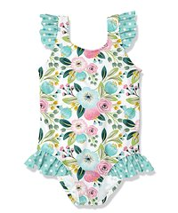RNYSIL101092 12m, 18m, 24m, 2T, 3T, 4T, 5, 6, 6x, 8, 10, 12
$14

6.
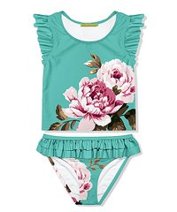NYSIL108008 12m, 18m, 24m, 2T, 3T, 4T, 5, 6, 6x, 8, 10, 12
$16

7.
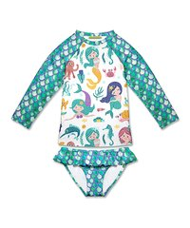NYSIL103166 12m, 18m, 24m, 2T, 3T, 4T, 5, 6, 6x, 8, 10, 12
$17

8.
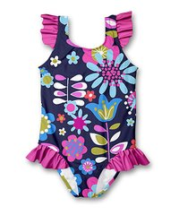NYSIL101207 12m, 18m, 24m, 2T, 3T, 4T, 5, 6, 6x, 8, 10, 12
$14

9.
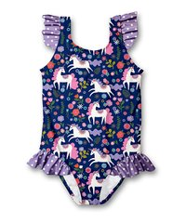NYSIL101205 12m, 18m, 24m, 2T, 3T, 4T, 5, 6, 6x, 8, 10, 12
$14

