Baby Dresses and Rompers Spring 2020

1.
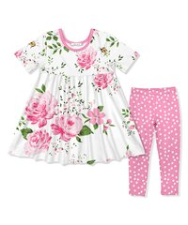FY28SIL77-A011 3m, 6m, 12m. 18m, 24m
$18

2.
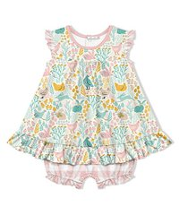FY28SIL75087 3m, 6m, 12m, 18m, 24m
$16

3.
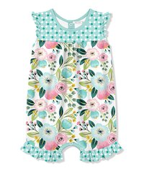FY28SIL83034 3m, 6m, 12m, 18m, 24m
$14

4.

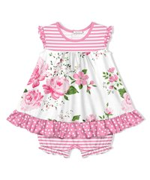FY28SIL75029 3m, 6m, 12m, 18m, 24m
$16

5.
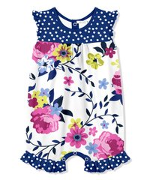FY28SIL83046 3m, 6m, 12m, 18m, 24m
$14

6.

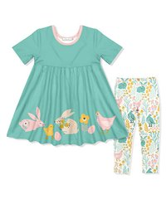FY28SIL77-A066 3m, 6m, 12m, 18m, 24m
$18

